ICEngineSoft Test Report

Report Date : Sun, Dec 18, 2022 , Time : 12:56:40 PM
Organization : Organisation, Operator : Operator
Data File : 18-12 T20 D80.xlsx, Last Modified Date: Sun, Dec 18, 2022,
Config. File : Kirloskar TV1 Engine.xls

Engine Details :

ICEngine set up under test is Kirloskar TV1 having power 5.20 kW @ 1500 rpm which is 1 Cylinder, Four stroke , Constant Speed, Water Cooled, Diesel Engine, with Cylinder Bore 87.50(mm), Stroke Length 110.00(mm), Connecting Rod length 234.00(mm), Compression Ratio 17.50, Swept volume 661.45 (cc)

Combustion Parameters :

Specific Gas Const (kJ/kgK) : 1.00, Air Density (kg/m^3) : 1.17, Adiabatic Index : 1.41, Polytrophic Index : 1.11, Number Of Cycles : 10, Cylinder Pressure Referance : 6, Smoothing 2, TDC Reference :-1

Performance Parameters :

Orifice Diameter (mm) : 20.00, Orifice Coeff. Of Discharge : 0.60, Dynamometer Arm Legnth (mm) : 185, Fuel Pipe dia (mm) : 12.40, Ambient Temp. (Deg C) : 27, Pulses Per revolution : 360, Fuel Type : Diesel, Fuel Density (Kg/m^3) : 831, Calorific Value Of Fuel (kj/kg) : 42880

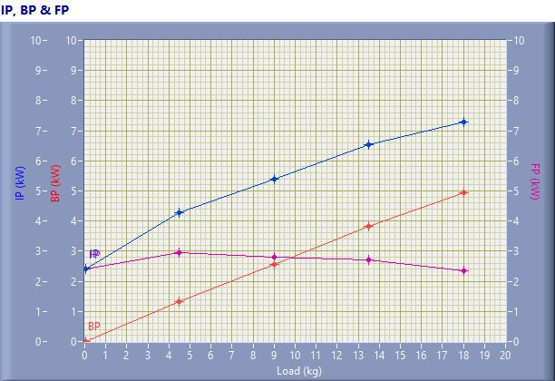

IP, BP & FP

Speed (rpm) | Load (kg) | IP (kW) | BP (kW) | FP (kW)
1554.00 | 0.03 | 2.41 | 0.01 | 2.40
1533.00 | 4.50 | 4.28 | 1.31 | 2.96
1499.00 | 9.01 | 5.38 | 2.57 | 2.82
1492.00 | 13.50 | 6.55 | 3.83 | 2.72
1438.00 | 18.03 | 7.29 | 4.93 | 2.36

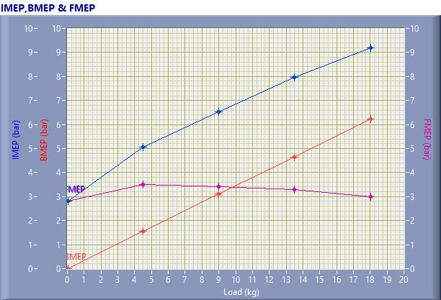

IMEP,BMEP & FMEP

Speed (rpm) | Load (kg) | IMEP (bar) | BMEP (bar) | FMEP (bar)
1554.00 | 0.03 | 2.81 | 0.01 | 2.80
1533.00 | 4.50 | 5.06 | 1.55 | 3.51
1499.00 | 9.01 | 6.51 | 3.11 | 3.41
1492.00 | 13.50 | 7.96 | 4.66 | 3.31
1438.00 | 18.03 | 9.20 | 6.22 | 2.98

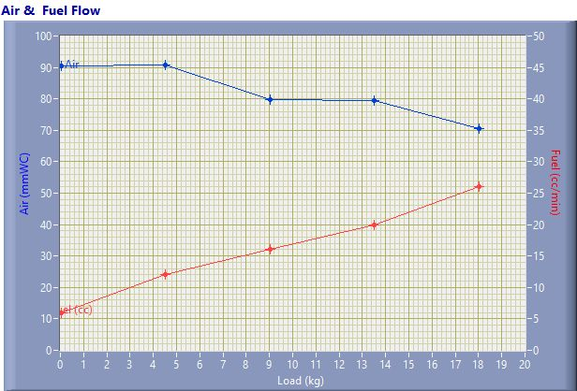

Air & Fuel Flow

Speed (rpm) | Load (kg) | Air (mmWC) | Fuel (cc/min)
1554.00 | 0.03 | 90.54 | 6.00
1533.00 | 4.50 | 90.79 | 12.00
1499.00 | 9.01 | 79.75 | 16.00
1492.00 | 13.50 | 79.36 | 20.00
1438.00 | 18.03 | 70.60 | 26.00

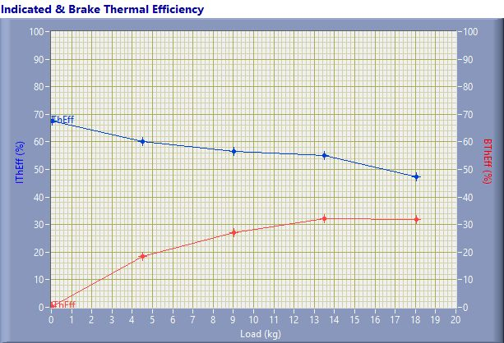

Indicated & Brake Thermal Efficiency

Speed (rpm) | Load (kg) | IThEff (%) | BThEff (%)
1554.00 | 0.03 | 67.57 | 0.27
1533.00 | 4.50 | 60.00 | 18.40
1499.00 | 9.01 | 56.65 | 27.02
1492.00 | 13.50 | 55.13 | 32.23
1438.00 | 18.03 | 47.23 | 31.92

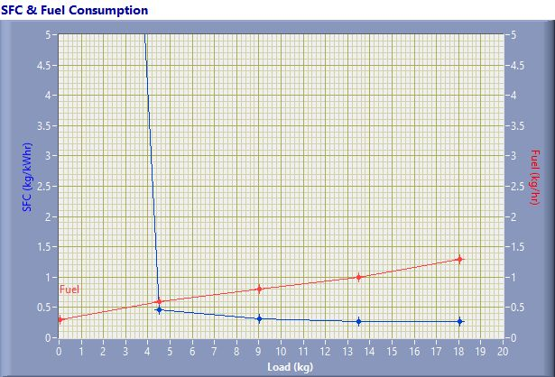

SFC & Fuel Consumption

Speed (rpm) | Load (kg) | SFC (kg/kWh) | Fuel (kg/h)
1554.00 | 0.03 | 31.65 | 0.30
1533.00 | 4.50 | 0.46 | 0.60
1499.00 | 9.01 | 0.31 | 0.80
1492.00 | 13.50 | 0.26 | 1.00
1438.00 | 18.03 | 0.26 | 1.30

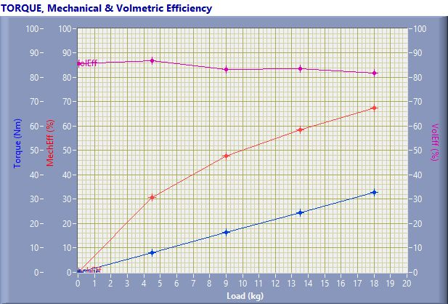

TORQUE, Mechanical & Volmertic Efficiency

Speed (rpm) | Load (Kg) | Torque (Nm) | Mech Eff. (%) | Vol Eff. (%)
1554.00 | 0.03 | 0.06 | 0.39 | 85.60
1533.00 | 4.50 | 8.17 | 30.68 | 86.89
1499.00 | 9.01 | 16.36 | 47.70 | 83.29
1492.00 | 13.50 | 24.50 | 58.47 | 83.48
1438.00 | 18.03 | 32.73 | 67.58 | 81.69

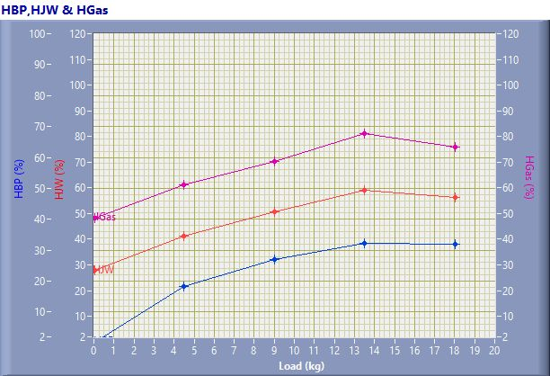

HBP,HJW & HGas

Speed (rpm) | Load (kg) | HBP (%) | HJW (%) | HGas (%) | HRad (%)
1554.00 | 0.03 | 0.27 | 27.63 | 20.47 | 51.64
1533.00 | 4.50 | 18.40 | 22.81 | 19.94 | 38.85
1499.00 | 9.01 | 27.02 | 23.48 | 19.67 | 29.82
1492.00 | 13.50 | 32.23 | 26.85 | 21.99 | 18.92
1438.00 | 18.03 | 31.92 | 24.35 | 19.75 | 23.99

Observation Data

Speed (rpm) | Load (kg) | Comp Ratio | T1 (deg C) | T2 (deg C) | T3 (deg C) | T4 (deg C) | T5 (deg C) | T6 (deg C)
1554 | 0.03 | 17.50 | 37.63 | 43.26 | 37.64 | 34.61 | 103.29 | 83.27
1533 | 4.50 | 17.50 | 37.84 | 47.13 | 37.84 | 37.65 | 174.01 | 130.38
1499 | 9.01 | 17.50 | 37.84 | 50.59 | 37.84 | 40.36 | 231.75 | 171.86
1492 | 13.50 | 17.50 | 37.89 | 56.11 | 37.89 | 43.83 | 311.89 | 225.19
1438 | 18.03 | 17.50 | 37.95 | 59.43 | 37.95 | 47.14 | 375.15 | 267.80

Observation Data

Air (mmWC) | Fuel (cc/min) | WaterFlow Engine (lph) | WaterFlow Cal (lph)
90.54 | 6.00 | 150 | 75
90.79 | 12.00 | 150 | 75
79.75 | 16.00 | 150 | 75
79.36 | 20.00 | 150 | 75
70.60 | 26.00 | 150 | 75

Result Data

Torque (Nm) | BP (kW) | FP (kW) | IP (kW) | BMEP (bar) | IMEP (bar) | BTHE (%) | ITHE (%) | Mech Eff. (%)
0.06 | 0.01 | 2.40 | 2.41 | 0.01 | 2.81 | 0.27 | 67.57 | 0.39
8.17 | 1.31 | 2.96 | 4.28 | 1.55 | 5.06 | 18.40 | 60.00 | 30.68
16.36 | 2.57 | 2.82 | 5.38 | 3.11 | 6.51 | 27.02 | 56.65 | 47.70
24.50 | 3.83 | 2.72 | 6.55 | 4.66 | 7.96 | 32.23 | 55.13 | 58.47
32.73 | 4.93 | 2.36 | 7.29 | 6.22 | 9.20 | 31.92 | 47.23 | 67.58

Result Data

Air Flow (kg/h) | Fuel Flow (kg/h) | SFC (kg/kWh) | Vol Eff. (%) | A/F Ratio | HBP (%) | HJW (%) | HGas (%) | HRad (%)
30.99 | 0.30 | 31.65 | 85.60 | 103.58 | 0.27 | 27.63 | 20.47 | 51.64
31.03 | 0.60 | 0.46 | 86.89 | 51.86 | 18.40 | 22.81 | 19.94 | 38.85
29.08 | 0.80 | 0.31 | 83.29 | 36.46 | 27.02 | 23.48 | 19.67 | 29.82
29.01 | 1.00 | 0.26 | 83.48 | 29.09 | 32.23 | 26.85 | 21.99 | 18.92
27.36 | 1.30 | 0.26 | 81.69 | 21.11 | 31.92 | 24.35 | 19.75 | 23.99

